Disabling Visuals Interaction

1. Creating a **Pie Chart**

Click on the Pie Chart. **Put Pattern in Legend and Qty in Values**

The Pie Chart **by default** shows the **percentage contribution** of each Pattern in the tool tip when mouse is hovered.

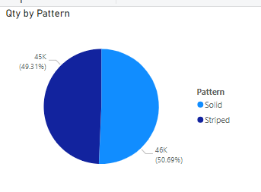

1. Creating a **Pie Chart**

Click on the Pie Chart. **Put Pattern in Legend , Qty in Values And Neck Style in Details**

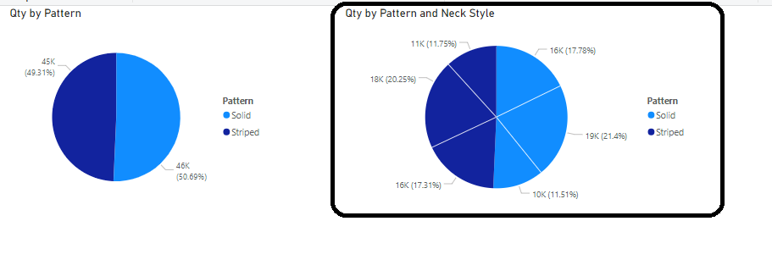

**Interactivity of Power BI Visuals**

Power BI visuals are interacting with each other. Selecting an item in a visual will effect on the display of another chart. Sometimes this effect is highlighting items in another chart, and sometimes filtering values in the other visual. By default, all visuals in a report page are interactive with each other.

**However, this interactivity can be disabled for some visuals!!!**

If on selection of first pie chart you **do not want** the 2nd chart getting affected then do the following:

1. Select the **first** chart
2. Select its **Format** tab
3. Click on the **Edit interactions** icon as shown next 🡪

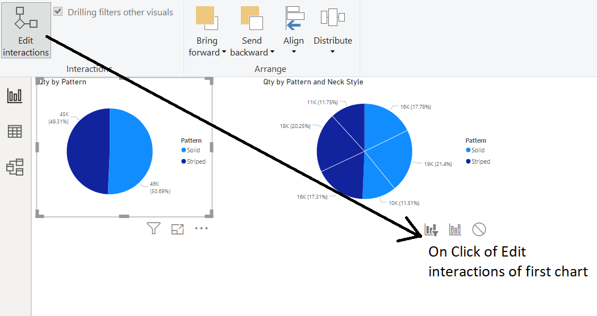

In the 2nd chart when the Filter icon is dark then it means filter will be applied. Click on the 3rd icon, i.e. circle.

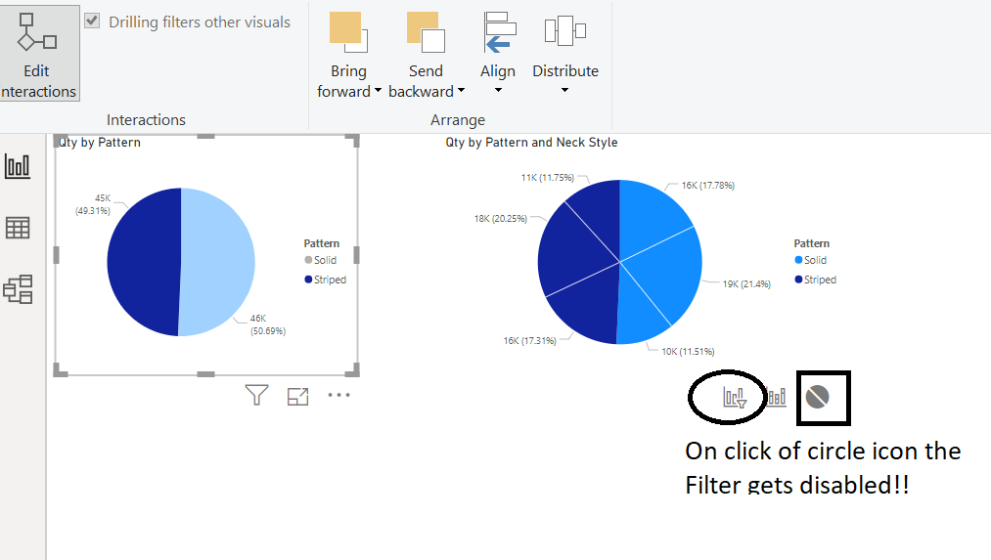

Again, to get back the filter functionality of 2nd chart just click on the first filter icon of it!!

**Real life example 🡪** In a sales dashboard, when a user changes currency of sales amount, it need not change percentage sales by-product since functionally these 2 charts may not be related.

**You can disable interactivity between components that are not functionally related.**